 | 12 ATAR Physics  EM1 Test 2017 Score: _______/ 52
  Student name:

Instructions:
Ignore Earth’s magnetic field unless question explicitly asks you to consider for realistic situations or qualitative arguments.

1. Describe TWO similarities and TWO differences between the gravitational field of a point mass and the electric field of a point charge. [4]

Similarities

(a)
(b)

Differences

(a)
(b)

Circle ONLY ONE correct answer for Multiple Choice Questions 2 to 5.

2. current I (into page)
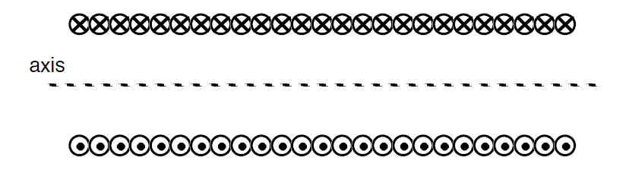
current I (out of page)

A cross section of a long solenoid that carries current I is shown above.
All of the following statements about the magnetic field B inside the solenoid are correct except

A. Magnetic field B is directed to the left.
B. The magnitude of B is proportional to the current I.
C. The magnitude of B is proportional to the number of turns of wire per
unit length.
D. The magnitude of B is proportional to the distance from the axis of the solenoid. [1]

3. A rod-shaped positively-charged insulator is brought near a conducting sphere, and the sphere is momentarily grounded as shown in Figure 1A.
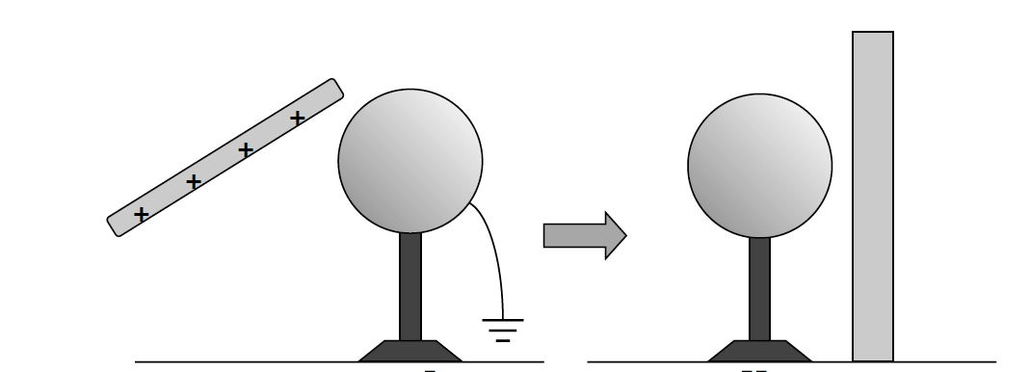
Figure 1A Figure 1B

The conducting sphere is then placed near a nonconducting plane as shown in Figure 1B. Which of the following statements is true for Figure 1B?

A. The conductor has a negative charge and is attracted to the nonconducting plane.
B. The conductor has a negative charge and is not attracted to the nonconducting plane.
C. The conductor has a positive charge and is attracted to the nonconducting plane.
D. The conductor has a positive charge and is not attracted to the nonconducting plane.
E. The conductor has no charge. [1]

4.
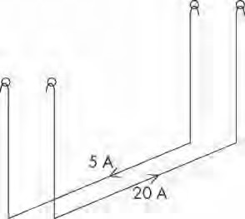

Note: To simplify the diagram, the external circuit has not been shown.

In an experiment to demonstrate the force between two wires carrying current, two identical long parallel wires are suspended from supports in such a way that a force between them will cause them to swing towards one another or away from one another.

A current of 5 A is then passed through wire A and 20 A through wire B.

If the currents flow in opposite directions, what will happen to the wires? [1]

A. A force of repulsion will appear between the wires and the wires will swing apart by equal amounts.

B. A force of repulsion will appear between the wires and the wires will swing apart, but wire B will swing out furthest.

C. A force of repulsion will appear between the wires and the wires will swing apart, but wire A will swing out furthest.

D. A force of attraction will appear between the wires and they will move towards one another by equal amounts.

5. The diagram shows a stationary conductor carrying current I amperes out of the page near to the magnet. In what direction will a magnetic force act on the conductor

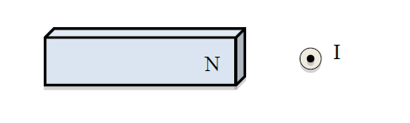
A. South B. West C. North D. East [1]

6. Figure 2 below shows two identical negatively charged conducting spheres. The spheres are tiny and each is suspended from a nylon thread.

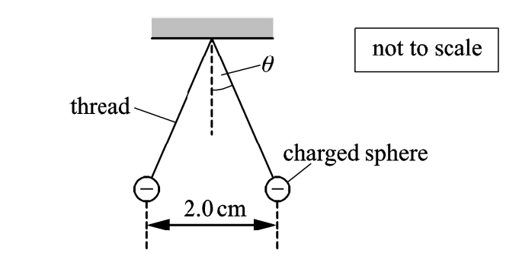

Figure 2

Each sphere has a mass of 6.0 x 10⁻⁵ kg and -4.0 x 10⁻⁵ C. The separation between the centres of spheres is 2.0 cm.

- Explain clearly why the spheres are separated as shown in Figure 2? [2]

- Calculate the angle θ made by each thread with the vertical. [4]

7. Figure 3 below shows two parallel vertical metal plates connected to a battery.

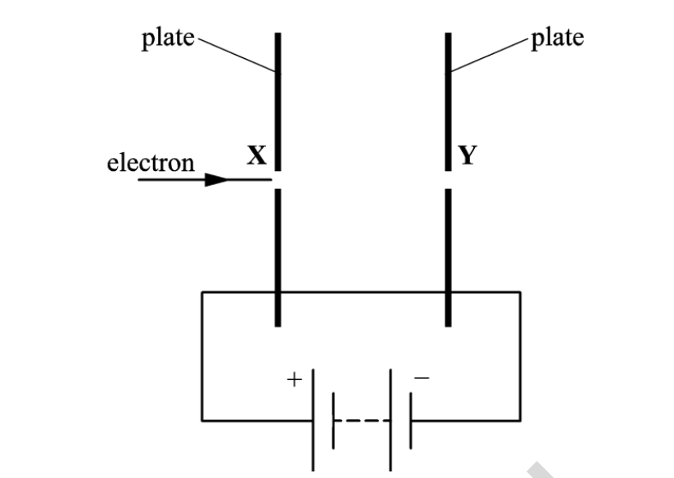

Figure 3

The plates are placed in a vacuum and have a separation of 1.2 cm. The uniform electric field strength between the plates is 1500 V m⁻¹. An electron travels through holes X and Y in the plates. The electron has a horizontal velocity of 5.0 x 10⁶ m s⁻¹ when it enters hole X.

- Draw five lines on Figure 3 to represent the electric field between the parallel plates. [2]

- Calculate the final speed of the electron as it leaves hole Y. [3]

8. Figure 4 shows the circular track of a positron (having a positive charge) in a uniform magnetic field.

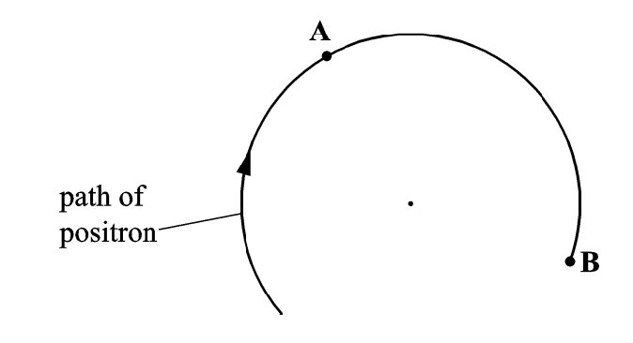
Figure 4

a) At point A, indicate the direction of the magnetic force acting on the positron. [1]

b) State the direction of the uniform magnetic field. [1]

c) Does the magnetic force change the speed of the positron? Justify. [2]

9. 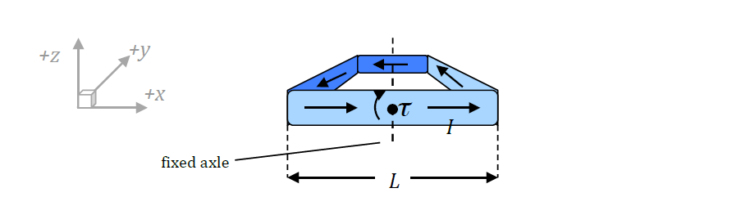

A square loop of wire, with sides of length L, is oriented in the x-y plane, and able to rotate in a clockwise direction about an axle along the y-axis and running through the middle of the loop, as shown.

The loop carries a current I in the direction indicated, and a constant magnetic field B is applied so as to create a clockwise torque.

a) State the direction of the magnetic field? Justify. [2]

b) Calculate the maximum magnitude of this torque in terms of L , B and current I ? Show clearly your working. [5]

10. The motor effect is used in a range of applications.

a) What is the motor effect? [2]

b) A labelled diagram of a loudspeaker is given below.

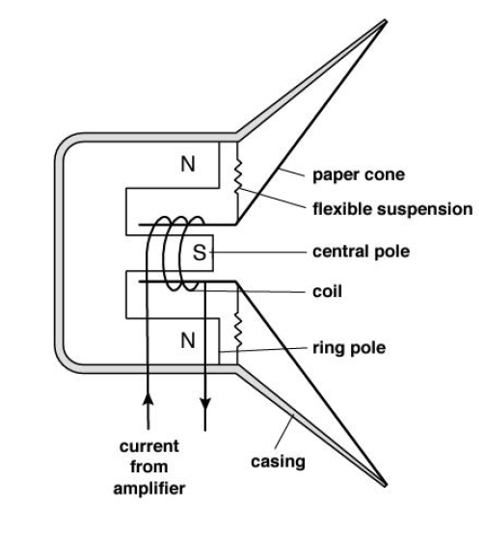

A Physics student has written the first statement to explain how a loudspeaker converts electrical signals into sound waves. Complete his explanation. [4]

- An alternating electrical current is applied to the coil in the loudspeaker.

11. A student uses a cathode gun to accelerate electrons to different velocities and then measures the radius of curvature of the path the electrons take in a magnetic field.

The electrons enter the magnetic field at right angles to the field. A diagram of the experiment and a graph of the results obtained by the student are shown below.

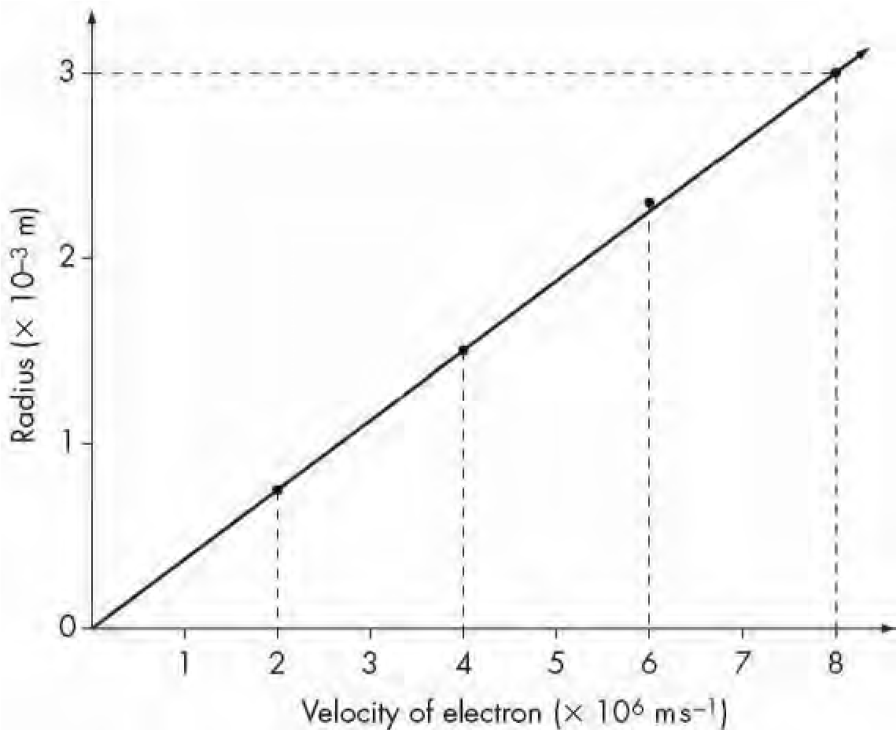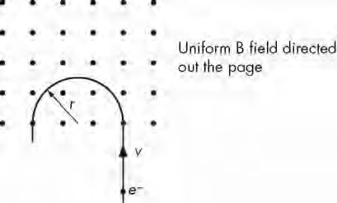

a) By equating the centripetal force and magnetic force on a charge moving perpendicularly to a magnetic field at a constant speed (v) derive a general expression for the radius of curvature of the charge in the field. [2]

b) Find the gradient of the graph. [2]

Question 11 (continued)

c) Calculate the strength of the magnetic field used in this experiment. [2]

d) (i) In the diagram below, sketch the magnetic field between the two
poles.
[1]

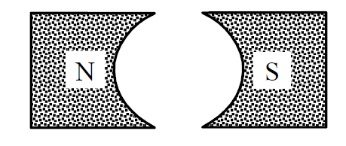

(ii) Identify the reason for using the above field in a motor. [1]

12. A wire carrying an electric current is placed between the poles of a horseshoe magnet. The 6.35 cm long conductor carries a current 4.8 A and the magnetic field between the poles of the magnet has a strength of 0.54 T.

- On the diagram, carefully illustrate the resultant magnetic field and the direction of the force experienced by the conductor? [3]

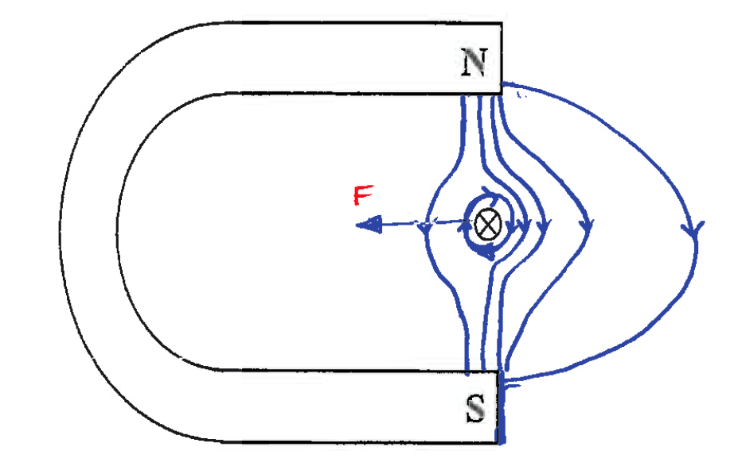
X

- Determine the magnitude of the force experienced by the conductor wire? [2]

13. Calculate the force on a small airplane which has acquired a net charge of 1550 µC and moves with a speed of 120 m s⁻¹ [3]

- parallel to the Earth’s magnetic field of 5 x 10⁻⁵ T ?

- perpendicular to the Earth’s magnetic field of 5 x 10⁻⁵ T ?

END OF TEST

